Contents

**What is START? 1**

**What is eCATT? 1**

**What is ECA? 1**

**START Tool Installation 1**

**Get access for ECA system 1**

**Prerequisites for START test case: 1**

**Creating new Test cases using Selenium: 1**

**Changing the existing test case: 1**

**Adding Custom Steps: 1**

**Secure Password: 1** **1**

**Test Configuration: 1**

**Log Information: 1**

**Jenkins Integration: 1**

**Information Links: 1**

# **What is START?**

Simple Test Automation for Regression Testing (START) is a test automation tool, with which automation can be achieved for any application developed using SAP UI Technologies (FIORI / UI5 / CRM WebUI / HTMLGUI) as early as the first UI screens are ready. START essentially employs record and replay method of automation.

# **What is eCATT?**

Extended Computer Aided Test Tool is a very successful automated testing tool that allows you to create automated functional test cases for the majority of applications running in SAP GUI for Windows/Java/HTML or WebDynpro environments. This tool has been in use for a decade to test SAPGUI based transactions by SAP internal and external customers.

# **What is ECA?**

ECA is an SAP Global test system for creating and maintaining the test automats with eCATT, START, etc.., The user creation for this system can be done through DLM’s centralized access provisioning. Link for the same: <http://dlm/cockpit>   .

# **START Tool Installation**

Please follow the below link for Installation.

[**https://wiki.wdf.sap.corp/wiki/display/STARTtool/START+Installation**](https://wiki.wdf.sap.corp/wiki/display/STARTtool/START+Installation)**.**

**START installation file:** \\dwdf030.wdf.sap.corp\builds\ClientInstallations\FiroiAndSeleniumSetups

Link folder and click on RunLatestFioriInstaller.bat file and select install START tool in local.

# **Get access for ECA system**

Need to create a DLM Incident under component DEV-ECATT-USER to get a user in ECA .

# **Prerequisites for START test case:**

In ECA system we need to create an HTTP type RFC destination for the test system using transaction SM59.

For HCP applications need to choose type-G type TFC.

The below document shows how to create a RFC and System Data Container(SDC) in below document.



After creating RFC we need to go /nsecatt command and click on System Data and give your created SDC and click on enter.

In that screen click on HTTP password and enter password for connecting to the cloud . This will run everytest case running before.

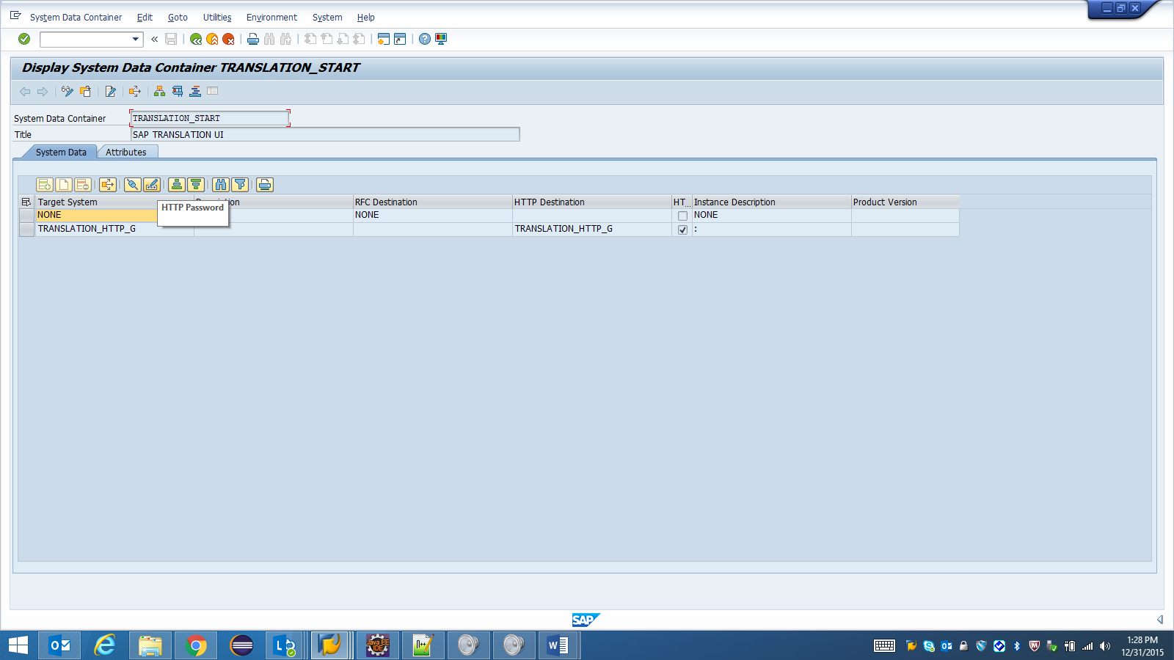

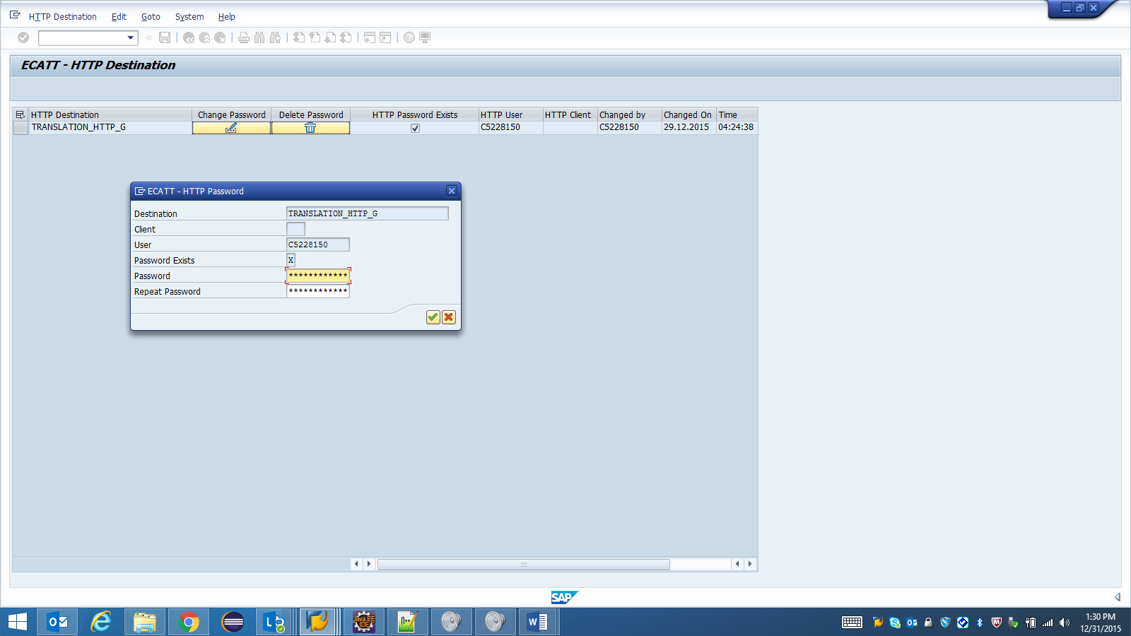

# **Creating new Test cases using Selenium:**

Please click the below .exe file and go to the Demo for creating a new test case in START tool step by step.



# **Changing the existing test case:**

Please click the below .exe file and go to the Demo for changing the existing test case in START tool step by step.



# **Adding Custom Steps:**

We can add our own selenium code which not supporting by START using below steps.

1. Go to the edit mode of the test case and select the step where you want to add new custom step and right click and select custom steps like below.

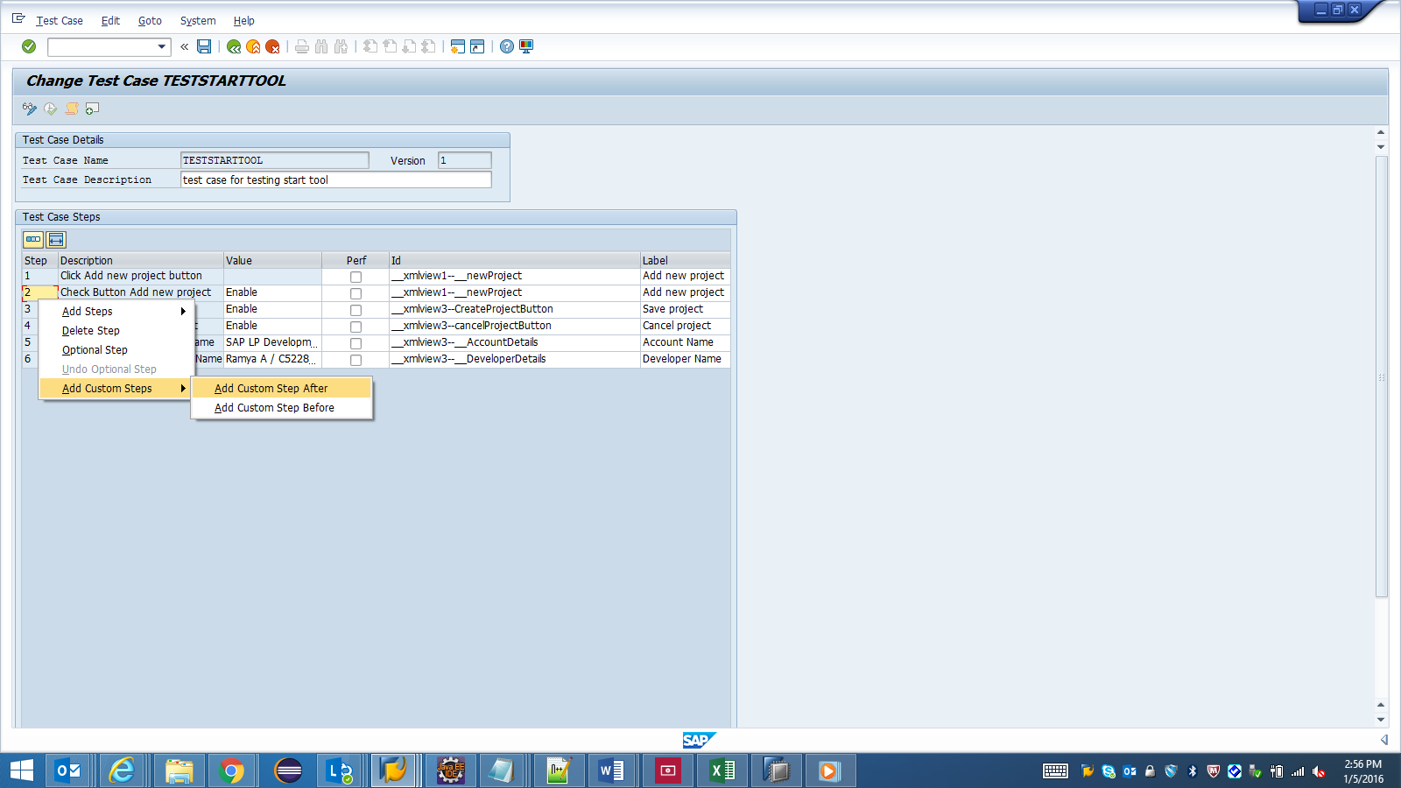

Select create or copy option and add custom steps in new opened window.

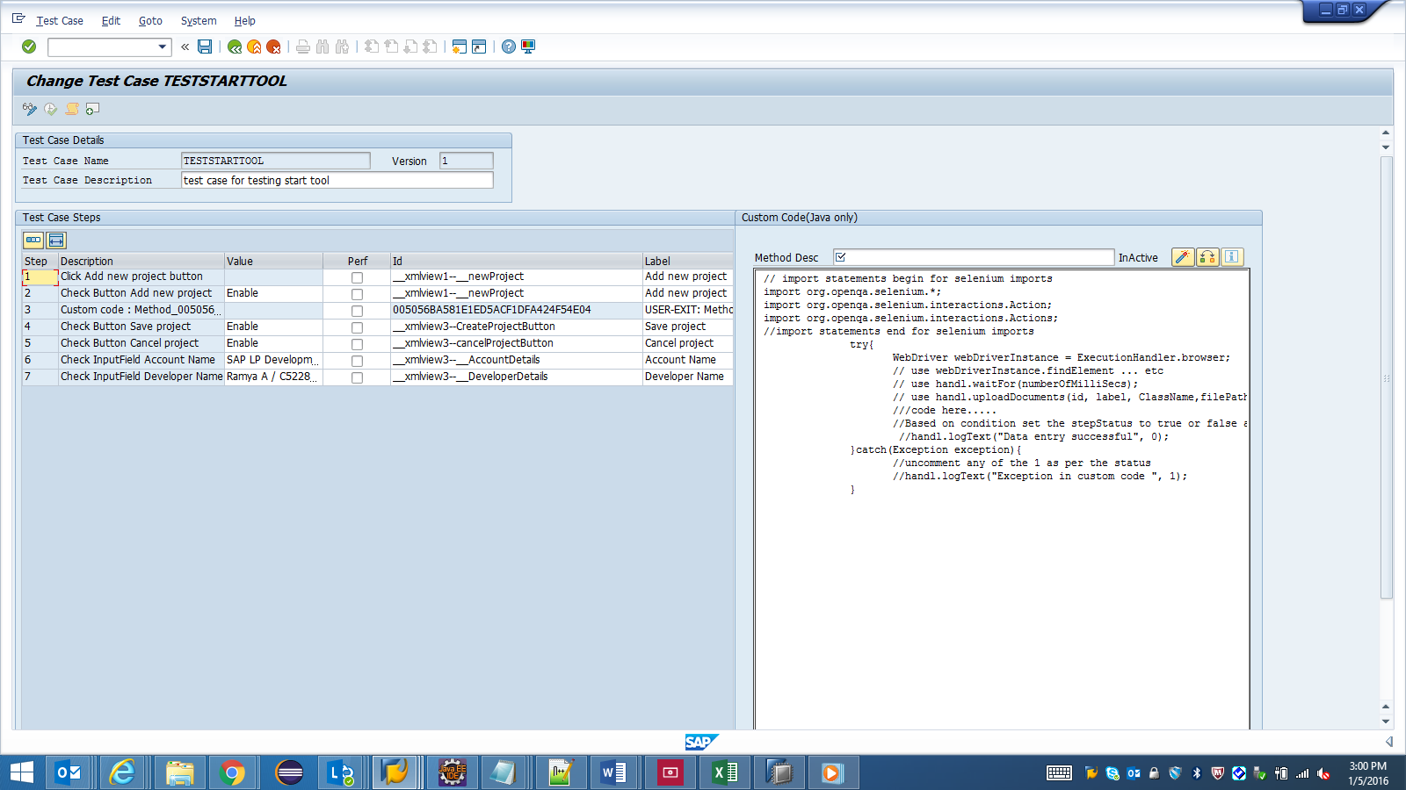

After adding selenium code in right side window give some name in Method Desc and need to click on active button next to the inactive label.

If there is no errors or everything fine with our custom code the Inactive label will show as active after clicking active button.

# **Secure Password:**

In our application we are pushing some data into Git using our login password.

While creating test case whatever you have used the password for pushing into git will be encoded and saved in $PASSWORD in testcase script.

while executing it will take from secure store and it will decode and give to the application.

Sure Store of password is shown in below

# 

# **Test Configuration:**

If we want use different values in the application dynamically then we have to use test configuration option.

Steps for Test Configuration.

1.We need to go to the test case and add some values in the input columns ,which values you need to take dynamically like below and save the test case.

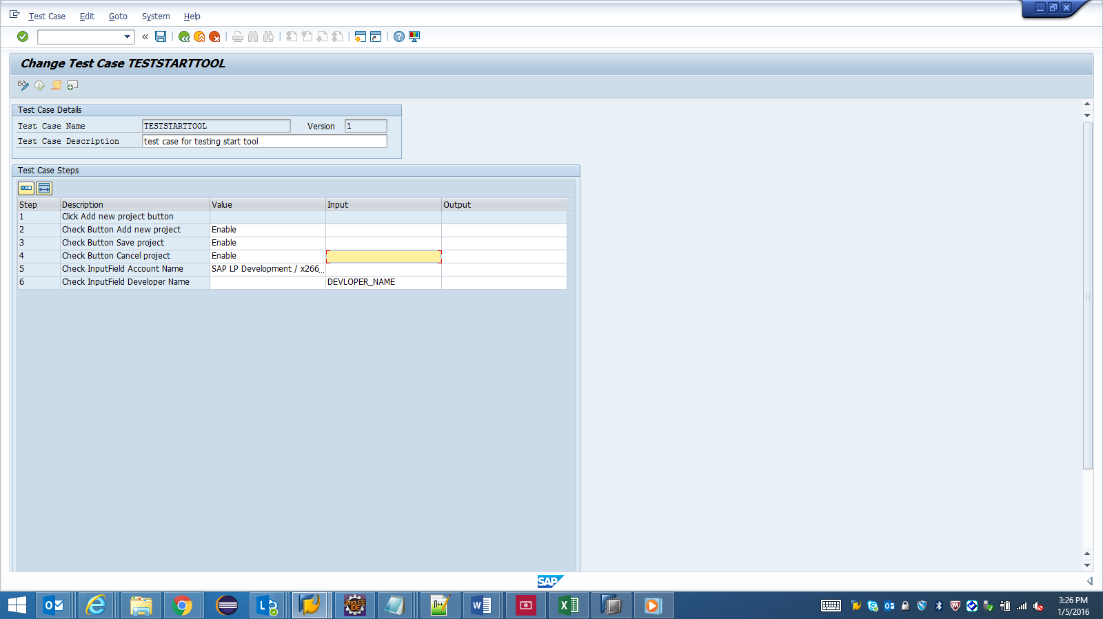

2. go to the /nsecatt transaction and select Test Configuration option and give your test case name and click on enter.

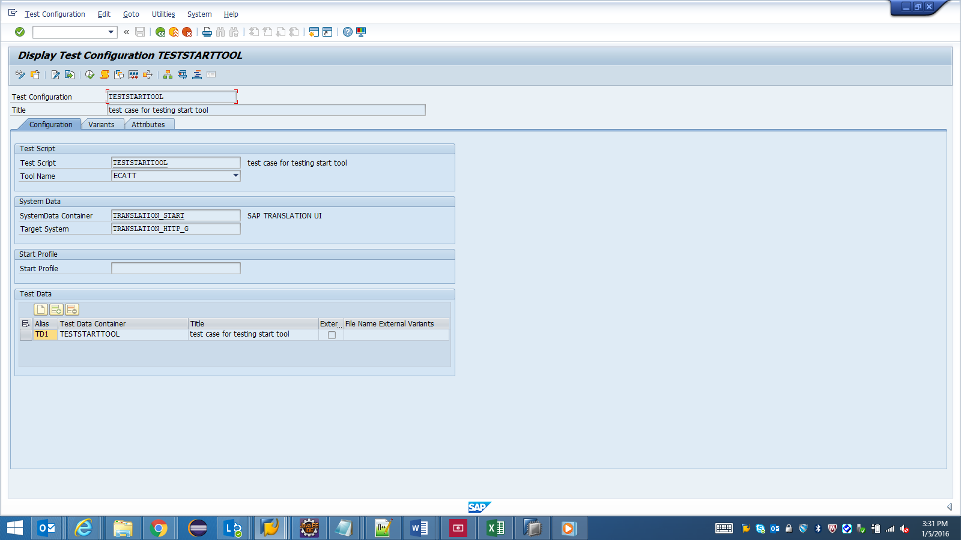

3. Select the variants tab and we can see the variable DEVELOPER_NAME .

In this window go to edit mode click on “InsertVariant” option give some name in variant and give the value what you want to show in UI will give under DEVELOPER_NAME .Click on save.

4. While executing test case it will take this variant value as DEVELOPER_NAME in UI.

# **Log Information:**

We can able to get the logs like each step execution status in test case can see the ErrorLog.txt file and if we have any compilation errors in custom code then we can see in ErrorLog1.txt file under ..user\Documents\SAP\SAP GUI.

# **Jenkins Integration:**

Need to create a job for running all start test cases on timely manner

Please go through the link for Jenkins integration with Start test cases:

<https://wiki.wdf.sap.corp/wiki/display/STARTtool/Scheduling+Mass+Execution+using+Jenkins>.

# **Information Links:**

For more information on START tool we can go through the below links:

“STARTer A First-Time-User Guide to the World of Automation using START” - <https://jam4.sapjam.com/blogs/show/HwDqW7fGa7YV2nOCBUP7vS>

“Test Automation – the Mantra for Success in Cloud” - <https://jam4.sapjam.com/blogs/show/iQEAyH7wOa85W5A9ss8H5r>

START Wiki - <https://wiki.wdf.sap.corp/wiki/display/STARTtool/START+Automation+Tool+Home>